Q1.
Answer is B.

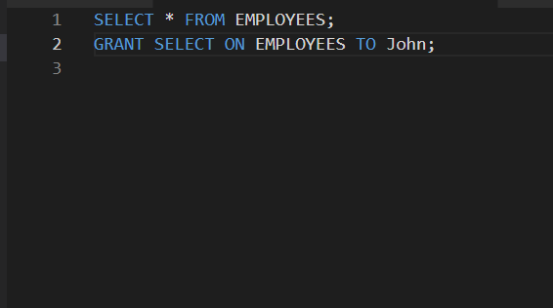

A: Incorrect. Option A reverses the order of TO JOHN and ON EMPLOYEES.

B: Correct. This syntax properly grants the SELECT privilege on the EMPLOYEES table to the user JOHN in Oracle SQL.

C: GIVE is not a valid SQL command in Oracle.

D: ALLOW is not a standard SQL command.

Q2.
Answer is B.

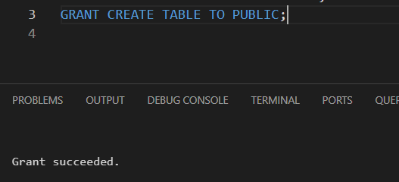

A: Incorrect. Oracle SQL does not have an ALL USERS keyword for granting privileges.

B: Correct. CREATE TABLE is a system privilege, so it can be granted directly to PUBLIC.

C: Incorrect. SYSTEM is not part of the GRANT syntax for a privilege.

D: Incorret. CREATE TABLE is a system privilege, not an object, so ALL ON is invalid here.

Q3.
Answer is A.

A: Correct.
GRANT SELECT ON CUSTOMERS TO ALICE → gives ALICE permission to select from the CUSTOMERS table.
WITH GRANT OPTION → allows ALICE to grant this privilege to other users.

B: Oracle SQL does not allow GRANT OPTION to be listed like a privilege.

C: CASCADE is not a valid clause in Oracle SQL for GRANT.

D: ALLOW is not a valid SQL command in Oracle.

Q4.
Answer is B.

A: Incorrect. In Oracle, the GRANT statement cannot combine privileges on multiple objects in one statement like this.

B: Correct. First create the role and assign table privileges to the role.

C: Incorrect. Oracle SQL does not allow specifying privileges in the CREATE ROLE statement.

D: Incorrect. This is not valid Oracle syntax.

Q5.
Answer is A.

REVOKE is the correct Oracle SQL command to remove privileges.

A: Correct. Removes the UPDATE privilege from user BOB on the PRODUCTS table.

B: Incorrect. Oracle SQL does not support REMOVE to revoke privileges.

C: Incorrect. DELETE is used for removing rows from tables, not for privileges.

D: Incorrect. UNSET is not a valid SQL command in Oracle.

Q6.
Answer is A.

A: Correct. In Oracle, CREATE PROCEDURE is a system privilege that allows a user to create procedures in their own schema only.

B: Incorrect. CREATE ANY PROCEDURE allows a user to create procedures in any schema.

C: Incorrect. Oracle SQL does not support IN OWN_SCHEMA in GRANT syntax.

D: Incorrect. Oracle SQL does not support IN SCHEMA in GRANT syntax.

Q7.
Answer is B.

A: Incorrect. Oracle SQL does not support WITH NO GRANT OPTION.

B: Correct. By default, granting a privilege without WITH GRANT OPTION means the user cannot grant it to others.

C: Incorrect. Oracle SQL does not support RESTRICT GRANT.

D: Incorrect. Oracle SQL does not support WITHOUT GRANT OPTION.

Q8.
Answer is C.

A: Incorrect. CREATE TABLE, ALTER TABLE, DROP TABLE are system privileges, but this syntax only allows creating/modifying/dropping tables in the user’s own schema.

B: Incorrect. Oracle SQL does not support ALL PRIVILEGES ON ALL TABLES.

C: Correct. CREATE ANY TABLE, ALTER ANY TABLE, DROP ANY TABLE are system privileges that allow a user to create, modify, or drop tables in any schema, not just their own.

D: Incorrect. Oracle SQL does not support FULL CONTROL ON TABLES.

